Cloud Offerings
What is Cloud ?
The "cloud" in technology refers to a global network of remote servers, accessed via the internet, that store and process data, deliver software, and provide computing resources like storage and databases, instead of relying on your local computer.
What is Cloud Platform?
A cloud platform refers to a base system that acts as an infrastructure and software platform that provides cloud services. There are various cloud platforms, such as Amazon Web Services (AWS), Microsoft Azure, Google Cloud Platform.
What is Cloud Offerings?
Cloud offerings are IT services you use over the internet instead of installing or owning the hardware/software yourself. We just rent and use — and pay only for what we use. Cloud offering and cloud services both are same.
There are different types of Cloud offerings.
- IaaS - Infrastructure as a Service
- PaaS – Platform as a Service
- SaaS – Software as a Service
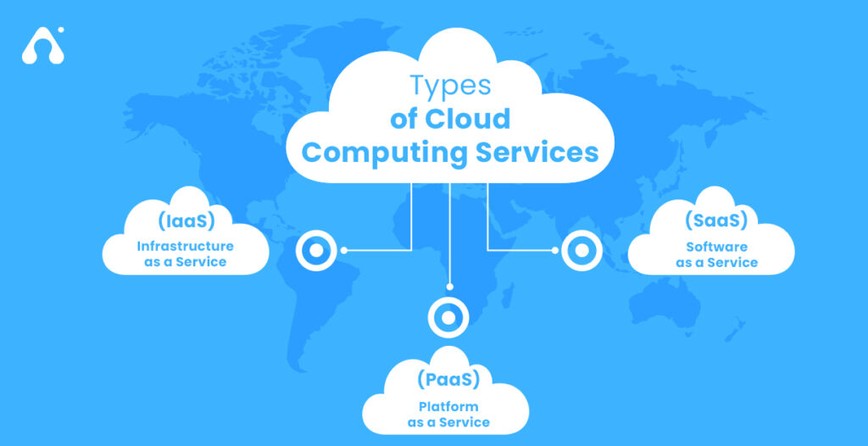

1.Infrastructure as a Service(IaaS):
IaaS or Infrastructure as a Service, is a cloud computing model that provides on-demand access to computing resources such as servers, storage, networking, and virtualization. We rent virtual hardware instead of owing servers.
Here we get – Virtual machines, Storage, Networks, Firewalls/Load balancers
User manage: OS, apps, runtime, data
Provider manages: hardware + virtualization
Examples: AWS EC2, Azure VM, Google Compute Engine
“When you want full control like a traditional server but hosted in cloud.”
Real time Examples –
Netflix — Streaming Platform
Netflix runs most of its infrastructure on AWS EC2, S3, CloudFront to stream movies worldwide.
2.Platform as a Service(PaaS):
Platform as a Service (PaaS) is a cloud computing model that provides developers with a complete, on-demand environment (hardware, operating systems, databases, development tools) to build, run, and manage applications, without the complexity of managing the underlying infrastructure. You rent a ready-to-use platform to build and deploy apps.
Here we get:
- Runtime environment
- Databases
- Dev tools
- OS managed for you
User manage: your app & data
Provider manages: platform + OS + infrastructure
Examples: AWS Elastic Beanstalk,
Azure App Service,
Google App Engine.
“Developers who want to focus only on coding (not servers).”

3.Software as a Service:
SaaS (Software as a Service) in cloud computing is a model where software applications are hosted by a provider and delivered to users over the internet, usually via a web browser, on a subscription basis. You use ready-made applications over the internet.
Provider manages everything.
You only use the app.
Examples: Gmail, Office 365, Salesforce, Zoom
“End-users who just need software.”
Quick Comparison:
Type | You Manage | Provider Manage
IaaS | Rent Virtual servers | AWS EC2
PaaS | Rent Development platform | Azure App service
SaaS | Use ready sotware | Gmail/Salesforce

Conclusion:
Cloud offerings make it possible for anyone — from startups to global companies — to build, deploy, and use applications without worrying about physical hardware. IaaS lets you rent servers, PaaS helps developers focus on coding, and SaaS delivers software directly to users. These real-time applications prove that the cloud isn’t just a buzzword — it’s how the world runs technology today.

